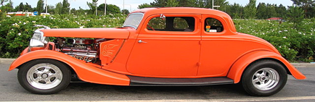

MAYFLOWER/LT. GAMBLE VFW POST 6695

IS HOSTING THE 2023 PLYMOUTH FALL FESTIVAL CLASSIC CAR SHOW ON
SEPTEMBER 9TH AND 10TH
JUDGING WILL BE FROM 9 AM – 1 PM. AWARDS WILL BE GIVEN EACH DAY
WITH THE MAIN AWARDS ON SUNDAY SEPTEMBER 10TH 2022 AT 2:00 PM

Registration is $15.00 per day of show (pay at gate)
IF PAYING BY CHECK MAKE PAYABLE TO: VFW Post 6695

Cars will park along Forest St. between Wing and Ann Arbor Trail
(enter off Harvey St. at Ann Arbor Trail)
SHOW OPEN TO ALL MAKES, MODELS AND YEARS
WWW.PLYMOUTHFALLFESTIVAL.COM

NAMES ___________________________________________________ CAR CLUB

ADDRESS _____________________________________________________________________ _____

CITY STATE ZIP EMAIL:

MAKE_________________________________MODEL_______________YEAR_________________________

DAYS_____ SATURDAY____________ SUNDAY_____________ BOTH DAYS_____________

If you have any question call Dave Henwood (313)-529-0953

